

OLX4030DT261B0

**硅麦克风产品规格书**

OLX4030DT261B0

数字硅麦克风

V1.0

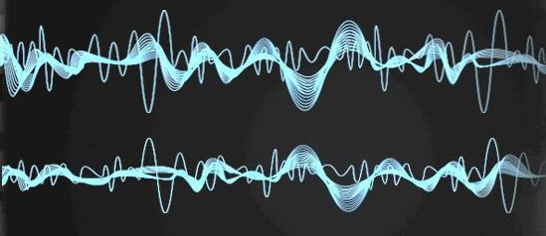

**产品说明**

OLX4030DT261B0是一颗高性能、低功耗、上部进声音的数字硅麦克风，组成麦克风的声学传感器、低噪音的输入缓冲器和输出放大器均适用于较宽的声学频域和RF自适应电路。

* 封装尺寸：4.0*3.0*1.0mm
* 输出信号：PDM信号
* LFRO:＜100Hz
* RoHS Compliance& Halogen Free
* 适用于表面贴装及高温回流
* 适用范围：适用于消费类电子的声音传输设备降噪及通话，包括但不限TWS耳机、手机、

Pad、智能音箱、投影设备、手持遥控设备等

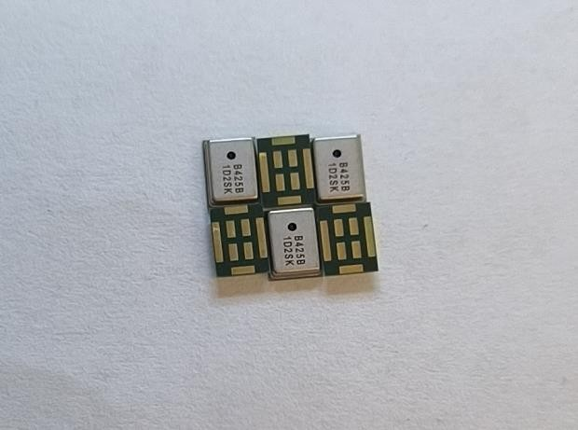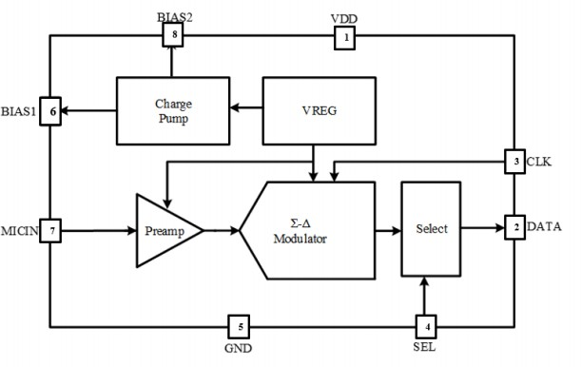



**1．声学和电学性能**

测试条件：除特殊注明外，均为Vdd=1.8V,23±2°C, 55±20% R.H.

**Electrical Characteristics**

|  |  |  |  |  |  |  |
| --- | --- | --- | --- | --- | --- | --- |
| Items | Symbol | Test Condition | Min. | Typ. | Max. | Unit |
| Power supply voltage | VDD |  | 1.6 | 1.8 | 3.6 | V |

**Standard Mode**

Test Condition: Measurement Clock Frequency 2.4 MHz, VDD = 1.8 V.

|  |  |  |  |  |  |  |
| --- | --- | --- | --- | --- | --- | --- |
| Items | Symbol | Test Condition | Min. | Typ. | Max. | Unit |
| Clock Frequency | Fclk |  | 1 | 2.4 | 4.8 | MHz |
| Directivity |  | Omni-directional | | | | |
| Sensitivity | S | 94dB SPL @1kHz | -27 | -26 | -25 | dBFS |
| Current Consumption | IDD | Normal mode |  | 750 | 1000 | μA |
| S/N Raito | SNR | 94dB SPL @1kHz A-  weighted |  | 58 |  | dB |
| Total Harmonic Distortion | THD | 94dB SPL @1kHz, |  |  | 0.5 | % |
| Acoustical Overload Point | AOP | 10% THD @1kHz |  | 116 |  | dBSPL |
| Power Supply Rejection | PSR | 100mVpp Square wave @217Hz, A-weighted |  | -90 |  | dBFS |

**Low Power Mode**

Test Condition: Measurement Clock Frequency 768 kHz, VDD = 1.8 V

|  |  |  |  |  |  |  |
| --- | --- | --- | --- | --- | --- | --- |
| Items | Symbol | Test Condition | Min. | Typ. | Max. | Unit |
| Clock Frequency | Fclk |  | 150 | 768 | 900 | KHz |
| Directivity |  | Omni-directional | | | | |
|  |  |  |  |  |  |  |
| Sensitivity | S | 94dB SPL @1kHz | -27 | -26 | -25 | dBFS |
| Current Consumption | IDD | Low power mode |  | 300 | 350 | μA |
| S/N Raito | SNR | 94dB SPL @1kHz A-  weighted |  | 58 |  | dB |
| Total Harmonic Distortion | THD | 94dB SPL @1kHz |  |  | 0.5 | % |
| Acoustical Overload Point | AOP | 10% THD @1kHz |  | 116 |  | dBSPL |
| Power Supply Rejection | PSR | 100mVpp Square wave @217Hz, A-weighted |  | -90 |  | dBFS |

**Operation Ratings**

|  |  |  |  |  |
| --- | --- | --- | --- | --- |
| Parameter | Symbol |  | Vales | Unit |



|  |  |  |  |  |  |  |  |  |  |
| --- | --- | --- | --- | --- | --- | --- | --- | --- | --- |
|  |  | |  | Note/Test Condition | Min | Typ. | Max |  |  |
| Power supply voltage | | VDD |  | 1.6 |  | 3.6 | V |
| Frequency Range | Sleep Mode |  |  | 0 |  | 50 | kHz |
| Low Power Mode |  |  | 150 | 768 | 900 | kHz |
| Standard Mode |  |  | 1 |  | 4.8 | MHz |
| Clock Duty Cycle | |  | 40 |  |  | 60 | % |
| Logic Input High | | *Vih* |  | 0.65*VDD |  | VDD+0.3 | V |
| Logic Input Low | | *Vil* |  | -0.3 |  | 0.35*VDD | V |
| Logic Output High | | *Voh* |  | VDD-0.45 |  |  | V |
| Logic Output Low | | *Vol* |  |  |  | 0.45 | V |
| Load Capacitance | |  |  |  |  | 140 | pF |
| Wake up time | |  |  |  |  | 30 | us |
| Mode Change Time | | *Tmc* |  |  |  | 10 | us |

# 2.频率响应曲线

**Frequency Response Curve**

8

6

4

2

0

-2

-4

-6

-8

-10

-12

10

100

**Frequency（Hz）**1000

10000

**Relative Response（dB）**



**3.应用电路**

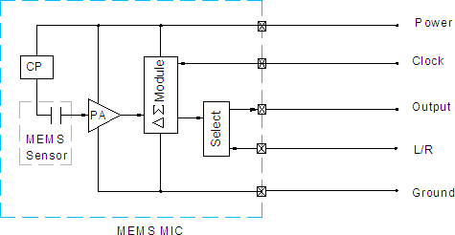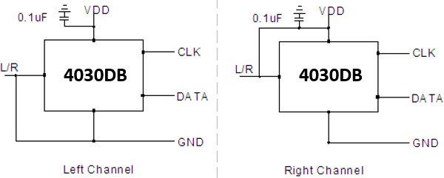

1. **测试框图**

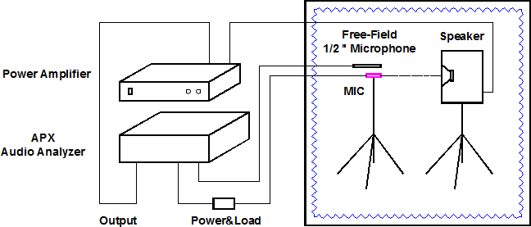

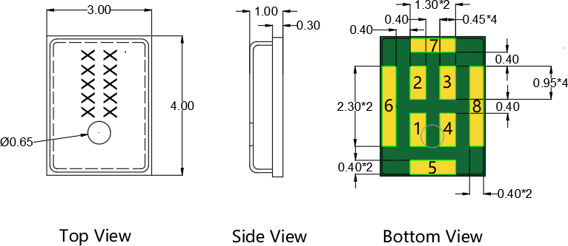

|  |  |  |  |
| --- | --- | --- | --- |
| Item | Dimension | Tolerance (+/-) | Units |
| Length(L) | 4.0 | 0.10 | mm |
| Width(W) | 3.0 | 0.10 | mm |
| Height(H) | 1.0 | 0.10 | mm |
| Acoustic Port(AP) | Ø0.65 | 0.05 | mm |

|  |  |  |
| --- | --- | --- |
| Pin # | Pin Name | Description |
| 1 | VDD | Power Supply |
| 2 | L/R | Channel select |
| 3 | CLK | PDM Clock input |
| 4 | Data | Output Signal |
| 5-8 | GND | Ground |

Notes: All dimensions are in millimeter (mm).

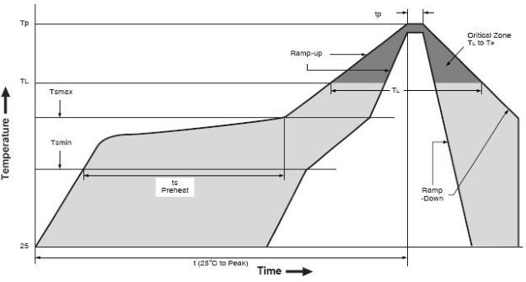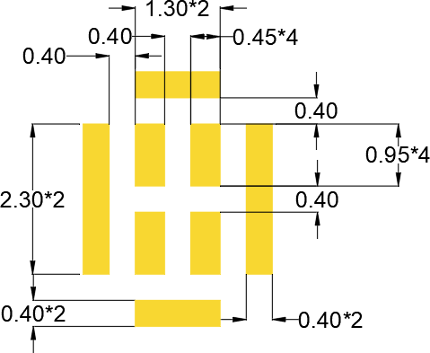

|  |  |
| --- | --- |
| 回流特点 | Pb-Free |
| 平均升温速率 (TSMAX to TP) | 3℃/second max. |
| 预热  最高温度 (TSMIN)  最低温度 (TSMAX)  时间 (TSMIN to TSMAX) (tS) | 150℃  200℃  60-180 seconds |
| 维持时间: 温 度 (tL)  时 间 (TL) | 217℃  60-150 seconds |
| 峰值温度 (TP) | 260℃ |
| 5℃内的真实峰值温度的时间 (tP) | 20-40 seconds |
| 降温速率(TP to TSMAX) | 6℃/second max |
| 25℃到峰值温度的时间 | 8 minutes max |

注释:

* 1. 回流时不允许完全覆盖声孔
  2. 回流后不能清洗载板
  3. 不允许对产品进行超声波清洗
  4. 不允许使用气枪等吹气设备直吹声孔
  5. 不允许对产品声孔进行吸真空操作
  6. 建议回流次数不超过3次

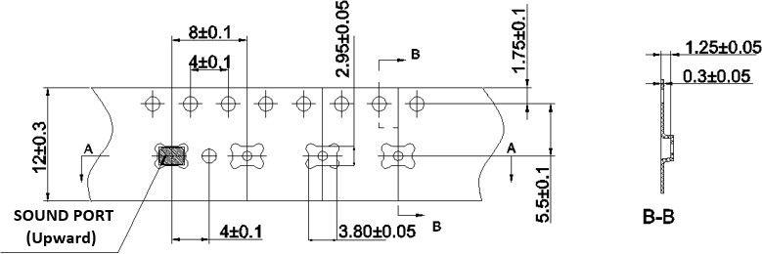

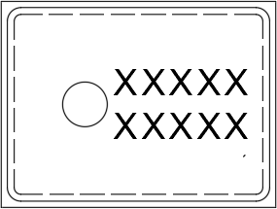

**包装数量**

|  |  |  |
| --- | --- | --- |
| 项目 | 载带盘直径 | 数量 |
| 规格 | 13寸 | 5000pcs |

# 8. 储存和运输

* 湿敏等级（MSL）: Class1
* 硅麦克风需存储在低于75%湿度的仓库内，需避免温度突变，避免接触酸性气体或者任何其他的有害气体或者强磁场；
* 未拆箱时推荐保存期不超过1年，拆箱后保存时间不超过4个周；
* 硅麦克风在正常包装情况下可以进行运输或者转运，请避免在运输过程中面临高湿、冲击、灼烧和压力等情况
* 储存温度：-40℃～+105℃ 工作温度：-40℃～+85℃

在温湿度可靠性实验后，麦克风灵敏度需要保持在±3dB以内；机械类可靠性实验后，麦克风灵敏度需要保持在±1dB以内.

|  |  |
| --- | --- |
| **测试项目** | **测试条件** |
| 温度冲击实验 | 从-40℃ 到 +105℃ 进行100个空气温度循环冲击 |
| 高温实验 | 在+105℃的环境下进行1000小时的放置实验 |
| 低温实验 | 在-40℃的环境下进行1000小时的放置实验 |
| 温湿度实验 | 在+85℃/85% R.H. 的温湿度下进行1000小时的放置实验 |
| 跌落实验 | 在1.5米高度将麦克风跌到钢板上，每次将3个方向跌落在钢板  表面 |
| 高温回流实验 | 进行5个回流的循环，最高回流温度在+260℃. |
| 静电实验 | C=150pF, R=330ohm.  外壳：测试 ±8KV 的接触外壳放电，3次  I/O脚：±2kV接触放电，3次 |
| 吹气实验 | 0cm 10S不低于0.5Mpa； 3cm 10S不低于0.5Mpa |



OLX4030DT261B0

**更改履历**

|  |  |  |
| --- | --- | --- |
| **版本** | **修改内容** | **日期** |
| 1.0 | 新下发 | 2023/09/10 |
|  |  |  |
|  |  |  |
|  |  |  |
|  |  |  |
|  |  |  |
|  |  |  |
|  |  |  |
|  |  |  |
|  |  |  |
|  |  |  |
|  |  |  |
|  |  |  |
|  |  |  |
|  |  |  |
|  |  |  |
|  |  |  |
|  |  |  |
|  |  |  |
|  |  |  |
|  |  |  |

10. 销售联系方式公司：深圳市欧力信科技有限公司  
地址：深圳市福田区华强北街道华航社区华富路1004号南光大厦806  
厂址 ：深圳市龙岗区深汕路292号银龙工业科技园A-5栋

电话： +86 82972990